Endocrine System

The endocrine system is a set of hormone secreting glands within the body of an animal.The endocrine system regulates the internal environment of the animal for growth, survival and reproduction as well as allowing it to respond to changes in its external environment.

An endocrine gland is a ductless organ that makes and secretes specific chemical messengers, called hormones, into the blood.

An exocrine gland has a duct that is used to carry the exocrine gland’s section to the outside of the body. Examples: sweat gland, tear gland, salivary gland.

A hormone is a chemical messenger secreted by an endocrine gland into the blood in which it is transported to specific target organs where a response is stimulated.

The other communication method in the body is the nervous system.

Difference between Nervous and Endocrine Control
- Nervous response is faster.
- Nervous response is shorter in duration.
- Nervous response stops quicker.
- Nervous response is much more local.
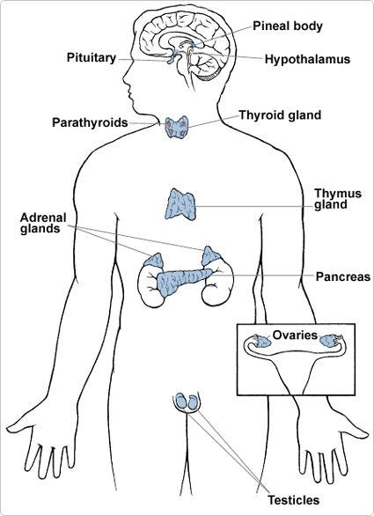
- Nerve ‘messages’ are conducted electrically; endocrine ‘messages’ are carried chemically.
Location of Endocrine Glands

Pituitary Gland produces many hormones such as
- Growth Hormone: stimulates growth and long bone elongation.
- Antidiuretic Hormone (ADH): causes increased water reabsorption by kidneys.
Thyroid secretes thyroxine that influences growth, development, and the rate of metabolism.
Islets of Langerhans of Pancreas: secrete insulin for tissue cells to take up glucose from the blood.
Adrenal Glands: located on top of each kidney, secrete adrenaline, prepares the body for stress — increases heart rate, blood pressure, breathing rate.

Ovaries: produces oestrogen which causes sexual maturation of females; repair of uterine lining after menstruation.
Testes: Testosterone: sexual maturation of males and has a role in sperm development.
Parathyroids embedded in thyroid make parathormone which releases calcium from bones into blood plasma.
Thymus under sternum makes thymosin which matures white blood cells.

Thyroxine

- Thyroxine is secreted by the thyroid gland.
- Thyroxine’s major functions are regulation of metabolic rate, growth and development.
- Iodine is needed for thyroxine formation.

Thyroxine Deficiency (Hypothryroidism)
Thyroxine secretion is below normal. Causes cretinism in childhood — poor growth and poor brain development. Causes myxoedema in adults — fatigue, low energy, reduced resistance to disease. goitre. A severe lack of iodine in the diet can cause hypothyroidism. Corrective Measures: hormone replacement therapy or iodine-rich diet.

Thyroxine Excess (Hyperthyroidism)
Thyroxine secretion is above normal. Causes raised metabolism, greater appetite, weight loss, general restlessness. Corrective Measures: drugs to suppress thyroid activity, surgically remove part of the gland, use radioactive iodine to destroy some of the gland.
Hormone Supplements
A specific hormone may be given to a patient suffering from hormone deficiency illnesses.
Examples:
- Insulin for the treatment of diabetes.
- Growth hormone for the treatment of potential dwarfism.
- Thyroxine for the treatment of potential cretinism.
- HRT (oestrogen) to reduce the severity of menopause symptoms.
Regulation of Thyroid Action
Example: role of thyroid in maintaining body temperature at 37°C.
- The hypothalamus of the brain detects a drop in blood temperature.
- The hypothalmus stimulates the pituitary to secrete TSH (thyroid-stimulating hormone).
- This hormone stimulates the thyroid to increase its secretion of thyroxine.
- The higher concentration of thyroxine increases metabolism and heat production increases. The blood is warmed back to normal temperature.
- Hypothalamus detecting raised blood temperature and reducing its stimulation of the pituitary. High thyroxine levels inhibiting the release of TSH from the pituitary which in turn reduces thyroxine production. This is an example of a negative feedback system.

